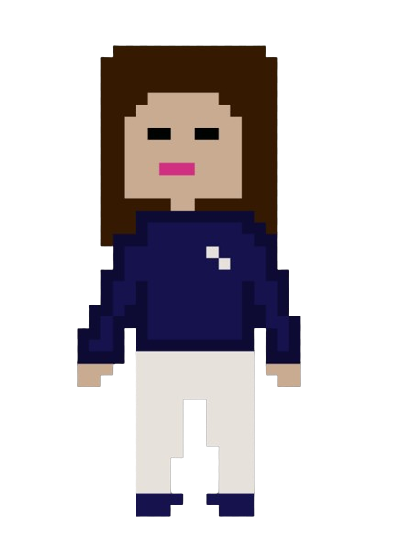

Contents

2

**1.** **ABOUT THE TEAM** 3

2. 1 THE IDEA 3

**3.** **USED TECHNOLOGIES** 4

**4.** **TABLE WITH FUNCTIONS** 4

**5.** **BLOCK SCHEME** 6

**ABOUT THE TEAM**

|  |  |  |
| --- | --- | --- |
| Team member | Role within the team | Class |
| Dimaya Noneva | Scrum Leader | 9B |
| Kaloyan Ivanov | Back-End developer | 9B |
| Stoyan Hristov | Back-End developer | 9B |
| Teodor Tanev | Q and A | 9B |
| Georgi Atanasov | Back-End developer | 9B |
| Georgi Filipov | Back-End developer | 9B |

1. **INTRODUCTION**

## 2. 1 THE IDEA

**Our goal is to provide access to an easier and more interesting way to study the material. We have created an online environment as close to the real world as possible, where anyone can register and have their own account. After each test, you will be graded based on the knowledge you have demonstrated. Join our challenge!**

2. 2 MAIN STAGES

|  |  |
| --- | --- |
| **FIRST WEEK** | Creating logo and discussing ideas about the game. |
| **SECOND WEEK** | Making the design and implementation our ideas through code. |
| **THIRD WEEK** | Developing the code |
| **FOURTH WEEK** | Creating the documentation and presentation. |

# **A beaker with yellow liquid Description automatically generatedUSED TECHNOLOGIES**

* **C++ as the main programming language.**
* **Raylib as an external library that for visualization.**
* **GitHub and Git is a cloud storage and control.**
* **Microsoft Office 365 suite for documentation preparation.**
* **Visual Studio 2022 as an integrated development environment.**
* **Canva for design.**
* **Blender – for creating the 3D objects.**

# **TABLE WITH FUNCTIONS**

|  |  |
| --- | --- |
| **Void** | **startingScreen();** |
| **Void** | **login();** |
| **Void** | **signup();** |
| **Void** | **select();** |
| **Void** | **mathsExaminationAlert();** |
| **Void** | **mathsExam();** |
| **Void** | **englishExaminationAlert();** |
| **Void** | **historyExaminationAlert();** |
| **Void** | **historyExam();** |
| **Void** | **historyExaminationAlert();** |
| **Void** | **literatureExam();** |
| **Void** | **literatureExaminationAlert();** |
| **Void** | **biologyExaminationAlert();** |
| **Void** | **biologyExam();** |
| **Void** | **geographyExaminationAlert();** |
| **Void** | **geographyExam();** |
| **Void** | **programmingExam();** |
| **Void** | **programmingExaminationAlert();** |
| **Void** | **chemistryExam();** |
| **Void** | **chemistryExaminationAlert();** |
| **Void** | **physicsExam();** |
| **Void** | **physicsExaminationAlert();** |
| **Void** | **pong();** |
| **Void** | **initMap(int character);** |
| **Void** | **menu();** |
| **Void** | **maths();** |
| **Void** | **biology();** |
| **Void** | **history();** |
| **Void** | **physics();** |
| **Void** | **geography();** |
| **Void** | **literature();** |
| **Void** | **chemistry();** |
| **Void** | **english();** |
| **Void** | **programming();** |
| **Void** | **physyicaEducation();** |
| **Void** | **drawFurnitures();** |
| **Void** | **collisions();** |
| **Void** | **drawFurnituresProgramming();** |
| **Bool** | **checkCollision();** |

# **BLOCK SCHEME**

